Weather part III: Weather Patterns-Prevailing Winds, Air Masses and Fronts
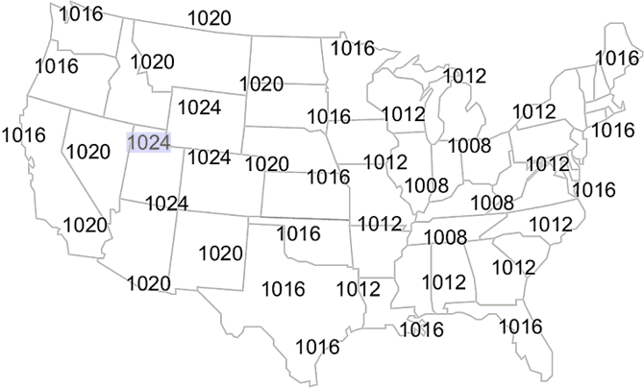
Name:___________________________________
Review of Drawing Isobars on a Map:
Normal Pressure Range on Earth’s Surface:

Air blows from _________ to _______ pressure.
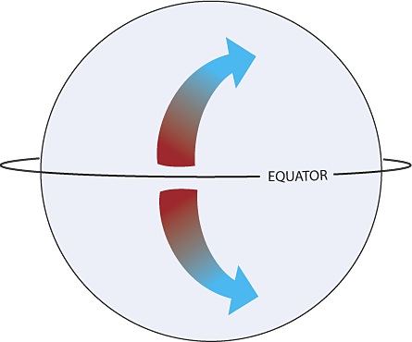
The Coriolis Effect
- Results from:_________________________________________________________________
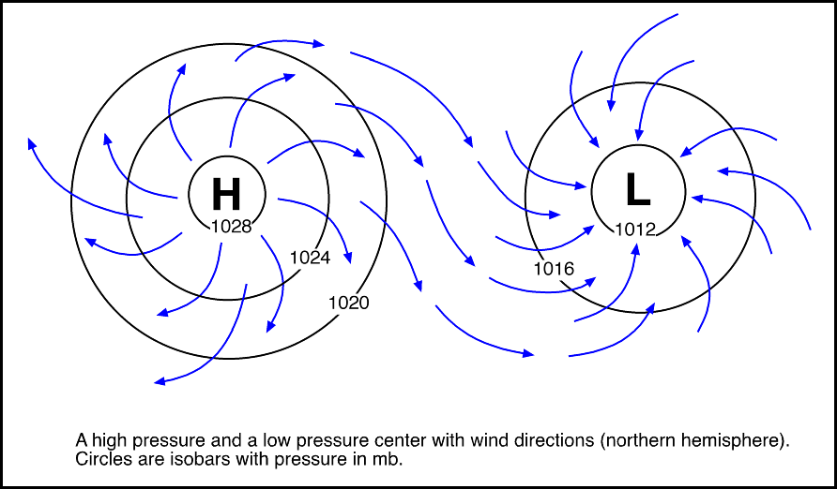
- Causes a deflection (curve) of path in:

Wind is deflected to the ______________ in the northern hemisphere, and the ___________ in the southern hemisphere.
A High Pressure System “Anticyclone:” _______________________
A Low Pressure System “Cyclone”: __________________________
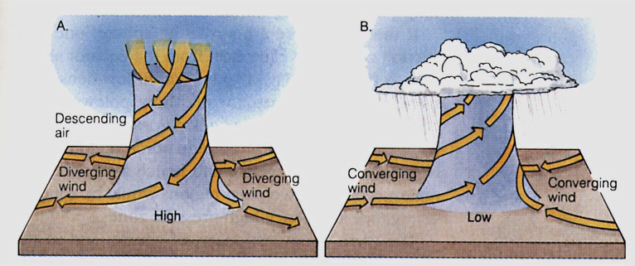
Cyclone: a low pressure system “________”on a synoptic map.
This is a zone of __________________________ at ground level because rising air at the center draws air ____________
Anticycone: “________” for high pressure system. These are areas of ________________ at ground level where sinking air at the center causes winds to blow ______________
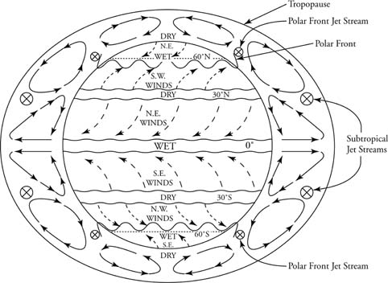
Planetary Wind and Pressure Belts: pg __________ of ESRT
- Air rises at equator _______ ˚ and at _________˚N/S. These latitudes are characterized by _________ ________
- Air sinks at ________˚ and __________˚ N/S. these latitudes are characterized by _________ _______________
- Because air flows from highlow pressure, these belts create our typical wind patterns called ___________________________
- Our prevailing winds in the USA between 30 and 60 ˚ N are called the:__________________________________________________
Monsoons: a seasonal prevailing wind in the region of South and Southeast Asia, blowing from the southwest between May and September and bringing rain (the wet monsoon ), or from the northeast between October and April (the dry monsoon).
What causes the difference in the monsoon seasons to occur as pictured below?

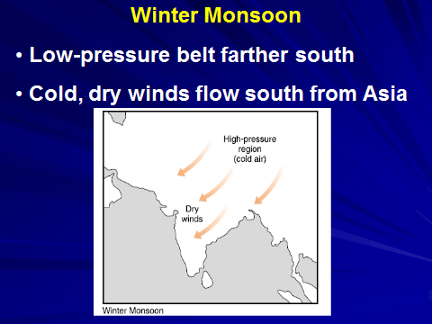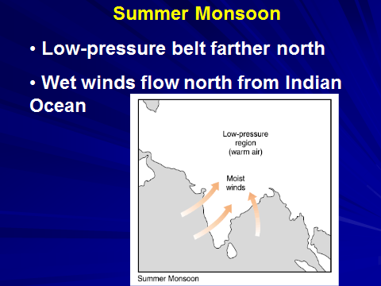
Air Masses- ________________________________________________________________________
Source Region- _____________________________________________________________________
Formed over the ocean: ____________________ Formed over the land:________________
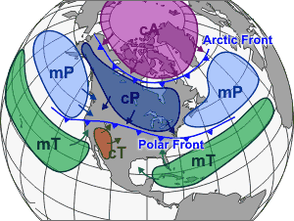
There are 5 types of air masses:
mT:
cT:
mP:
cP:
cA:

Front System: ________________________________________________________________________________
- Fronts are named after the air mass _______________ them and bring about changes in _________________
- There are 4 different types of fronts:

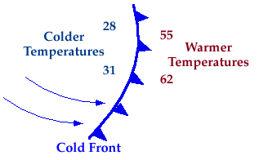
The Cold Front
-Advances ________________
-Forces warmer air to rise, expand, cool & causes rapid ____________________ and _________________________ as to as the front passes, ____________ air pressure
-Is followed by ______________, ______________ weather and __________ air pressure once the front has passed
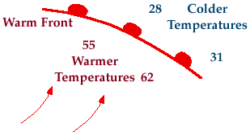
The Warm Front
-Moves _________________
-Warm moist air rises over cooler air & cools by expansion, which leads to formation of ______________________ ____________ which thicken over time. __________________________________ precipitation, but steady as the front ________________ (_______________________________________)
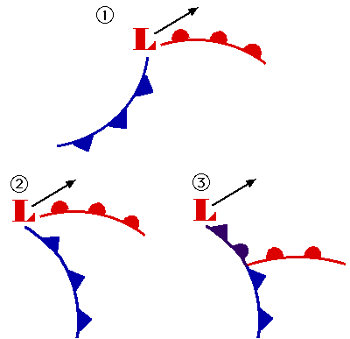
-Associated with _______________, and sometimes _______________ air followed by ______________ atmospheric pressure after front passes.
The Occluded Front
-Occurs when an advancing _________ air mass pushes a lighter __________ air mass _____________ (above ground)
-Associated with __________________________________ of _____________ and unsettled weather
-Once it has passed, the conditions are similar to a ___________________ front
Stationary Front
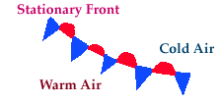
Occurs when winds blow in ___________________ directions along a ____________and ______________ air boundary OR neither air mass is powerful enough to ________________ the other
-little or ________________________ but dissipates over a few ______________
-clouds, precipitation and possibility of _________________________________can occur if the air is very _________________
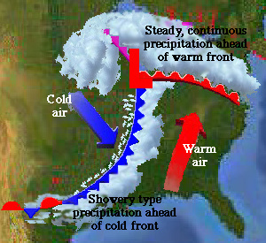
A Look at the movement of a typical mid-latitude cyclonic storm system
Where is precipitation occurring with respect to the fronts ?

Where will temperatures warm? Where will they cool?

What happens to barometric pressure as a front approaches?

